**MySql Task**

**Create Database and Tables**

**-- Create the database named 'ecommerce'**

CREATE DATABASE ecommerce;

**-- Switch to the 'ecommerce' database**

USE ecommerce;

**Output:**

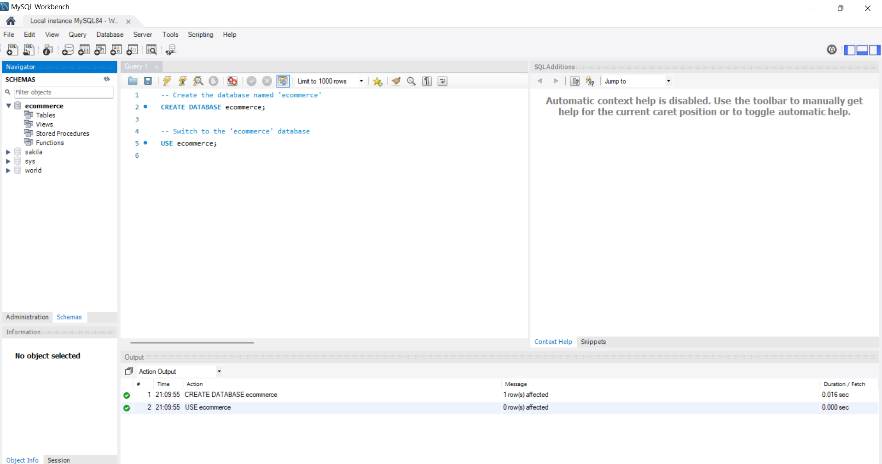

**-- Create the 'customers' table to store customer details**

CREATE TABLE customers (

id INT AUTO_INCREMENT PRIMARY KEY, -- Unique identifier for each customer

name VARCHAR(255) NOT NULL, -- Name of the customer

email VARCHAR(255) NOT NULL UNIQUE, -- Email address of the customer

address TEXT NOT NULL -- Address of the customer

);

**-- Create the 'products' table to store product details**

CREATE TABLE products (

id INT AUTO_INCREMENT PRIMARY KEY, -- Unique identifier for each product

name VARCHAR(255) NOT NULL, -- Name of the product

price DECIMAL(10, 2) NOT NULL, -- Price of the product

description TEXT NOT NULL -- Description of the product

);

**-- Create the 'orders' table to store order details**

CREATE TABLE orders (

id INT AUTO_INCREMENT PRIMARY KEY, -- Unique identifier for each order

customer_id INT NOT NULL, -- ID of the customer who placed the order

order_date DATE NOT NULL, -- Date the order was placed

total_amount DECIMAL(10, 2) NOT NULL, -- Total amount for the order

FOREIGN KEY (customer_id) REFERENCES customers(id) -- Link to the 'customers' table

);

**Output:**

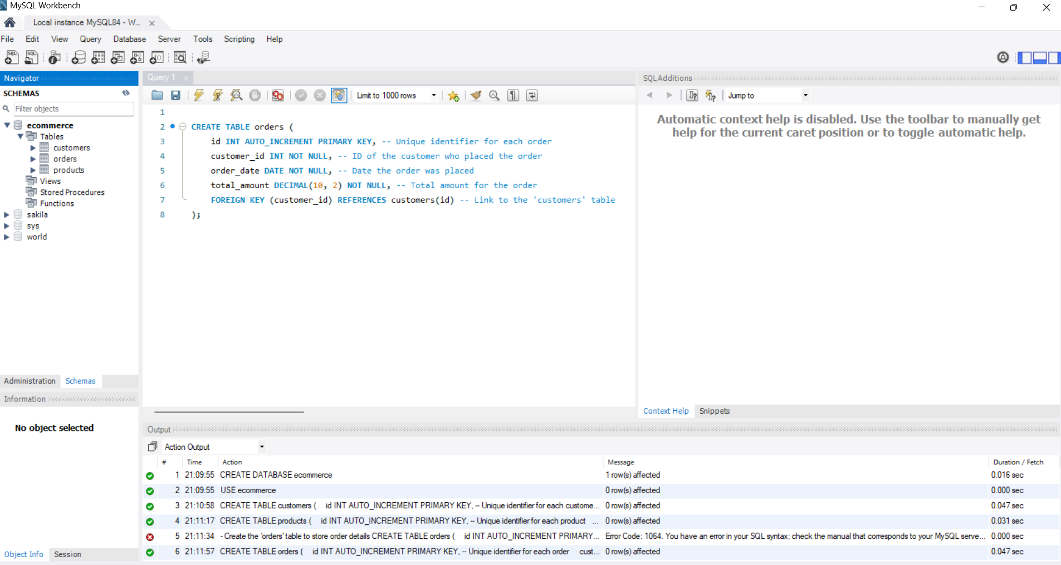

**2. Insert Sample Data**

**-- Insert sample data into the 'customers' table**

INSERT INTO customers (name, email, address)

VALUES

('John Doe', 'john.doe@example.com', '123 Elm Street'),

('Jane Smith', 'jane.smith@example.com', '456 Oak Avenue'),

('Alice Brown', 'alice.brown@example.com', '789 Maple Drive');

**-- Insert sample data into the 'products' table**

INSERT INTO products (name, price, description)

VALUES

('Product A', 25.00, 'Description of Product A'),

('Product B', 35.00, 'Description of Product B'),

('Product C', 40.00, 'Description of Product C');

**-- Insert sample data into the 'orders' table**

INSERT INTO orders (customer_id, order_date, total_amount)

VALUES

(1, CURDATE(), 60.00), -- Today's date

(2, CURDATE() - INTERVAL 20 DAY, 100.00), -- 20 days ago

(3, CURDATE() - INTERVAL 45 DAY, 75.00); -- 45 days ago

**Output:**

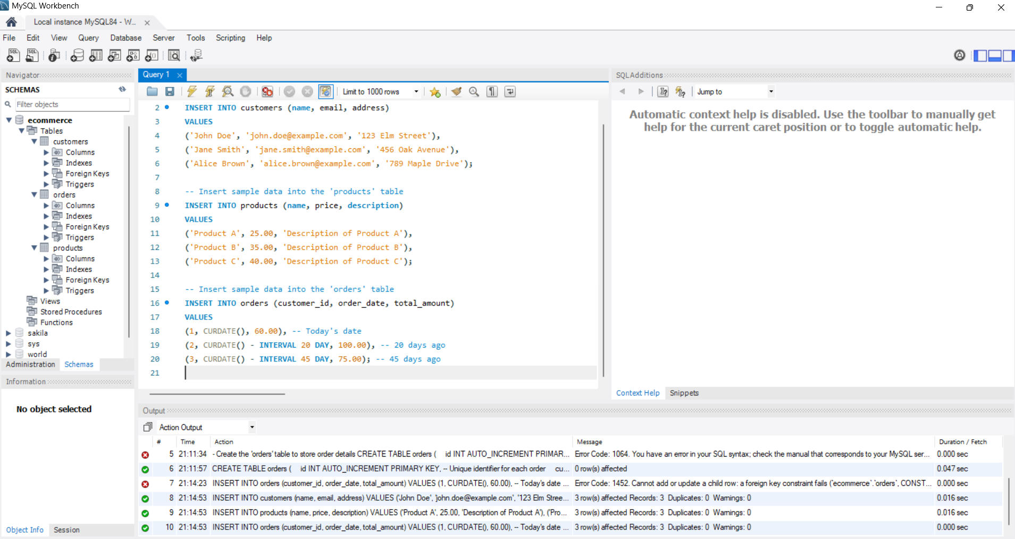

**3. Queries**

**a. Retrieve all customers who have placed an order in the last 30 days**

**-- Select customers who have placed an order within the past 30 days**

SELECT DISTINCT c.name, c.email

FROM customers c

JOIN orders o ON c.id = o.customer_id

WHERE o.order_date >= CURDATE() - INTERVAL 30 DAY;

**Output:**

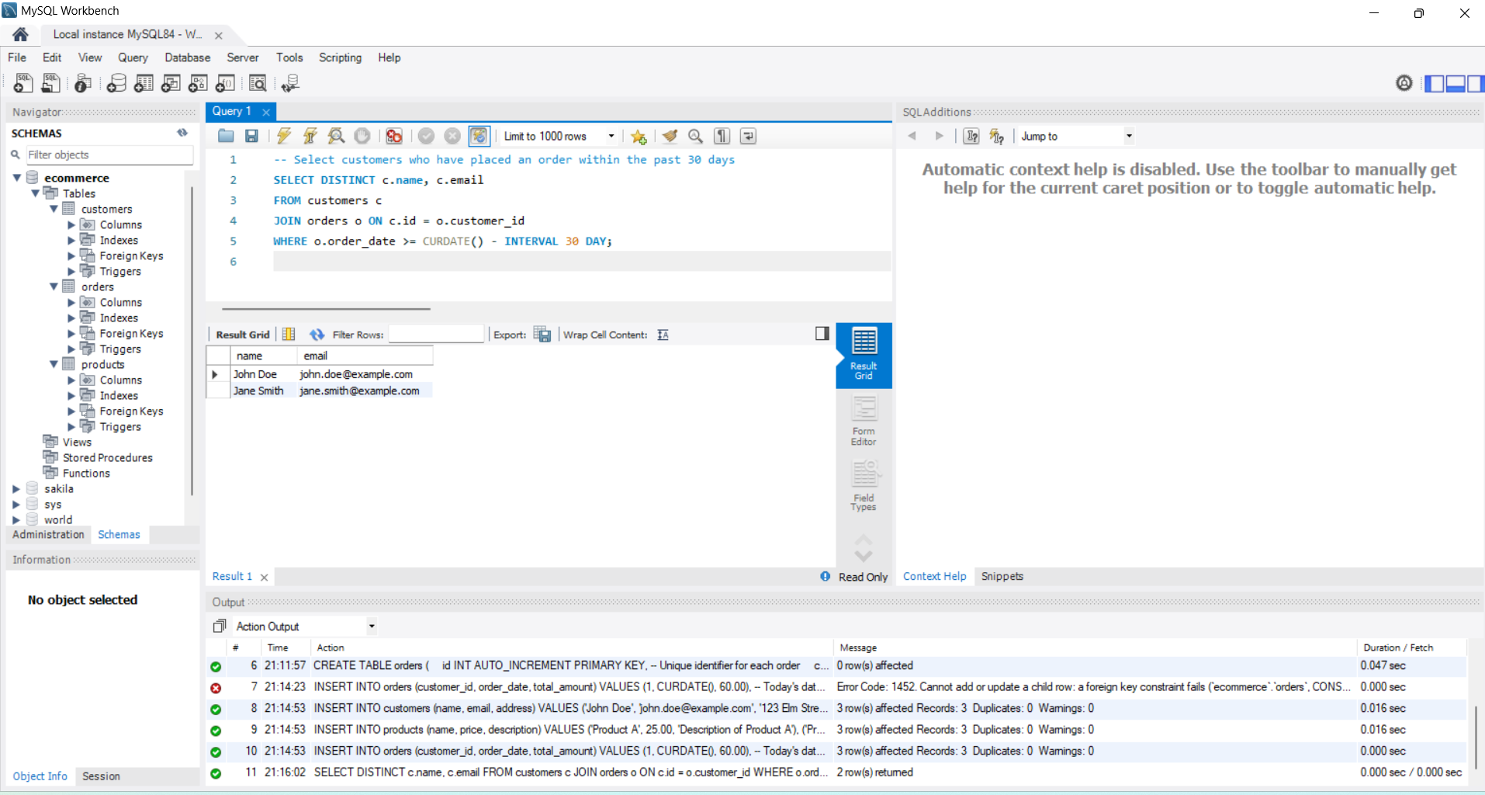

**b. Get the total amount of all orders placed by each customer**

**-- Calculate the total order amount grouped by each customer**

SELECT c.name, c.email, SUM(o.total_amount) AS total_spent

FROM customers c

JOIN orders o ON c.id = o.customer_id

GROUP BY c.id;

**Output:**

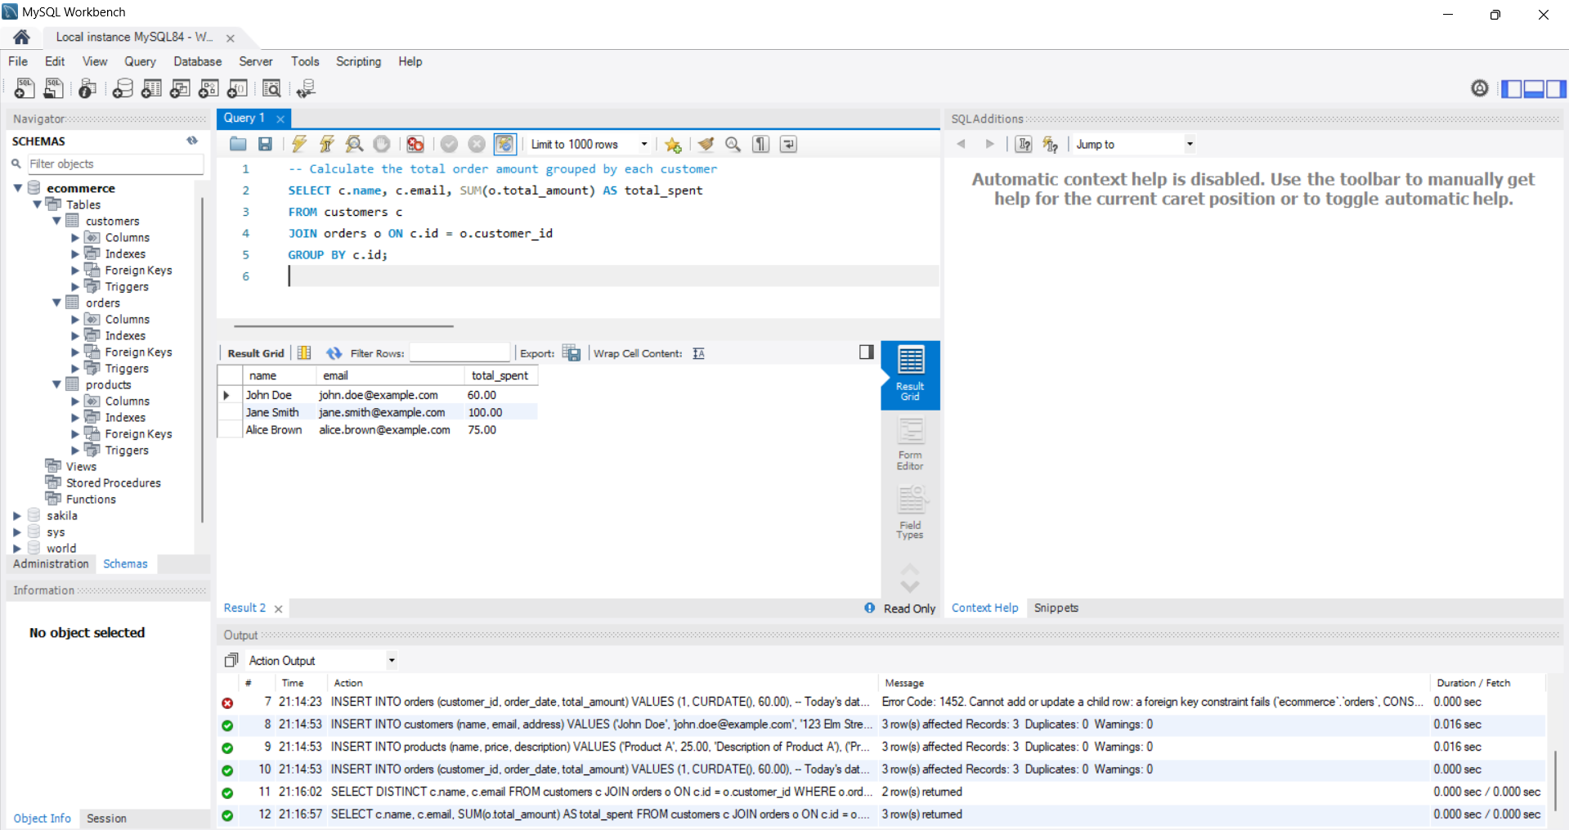

**c. Update the price of Product C to 45.00**

**-- Update the price of 'Product C' to 45.00**

UPDATE products

SET price = 45.00

WHERE name = 'Product C';

**Output:**

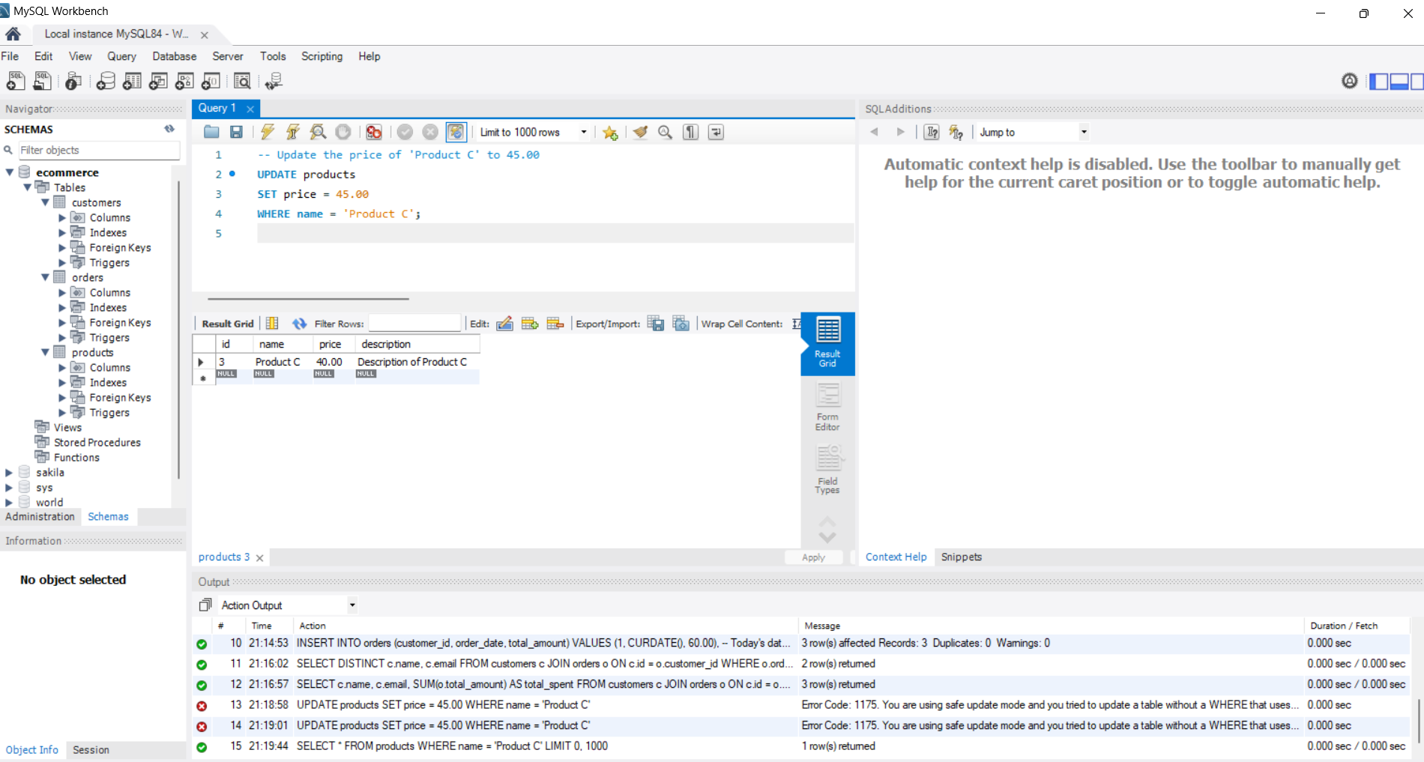

**d. Add a new column discount to the products table**

**-- Add a new column named 'discount' with a default value of 0.00**

ALTER TABLE products

ADD COLUMN discount DECIMAL(5, 2) DEFAULT 0.00;

**e. Retrieve the top 3 products with the highest price**

**-- Fetch the top 3 most expensive products**

SELECT name, price

FROM products

ORDER BY price DESC

LIMIT 3;

**Output:**

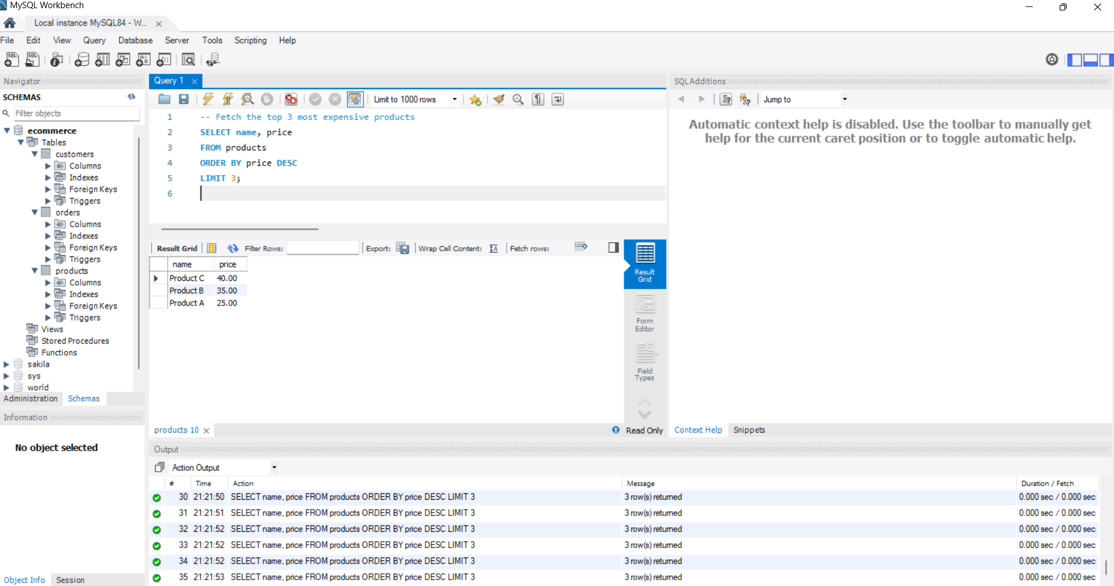

**f. Get the names of customers who have ordered Product A**

**-- Retrieve names of customers who have ordered 'Product A'**

SELECT DISTINCT c.name

FROM customers c

JOIN orders o ON c.id = o.customer_id

JOIN order_items oi ON o.id = oi.order_id

JOIN products p ON oi.product_id = p.id

WHERE p.name = 'Product A';

**Output:**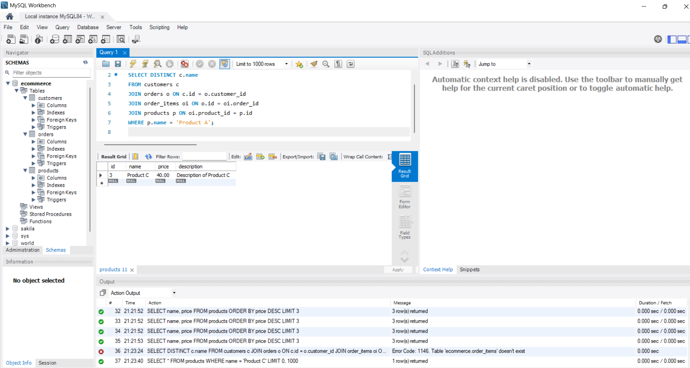

**g. Join orders and customers tables to retrieve customer name and order date**

-- Get the customer's name and the date of each order

SELECT c.name AS customer_name, o.order_date

FROM orders o

JOIN customers c ON o.customer_id = c.id;

**Output:**

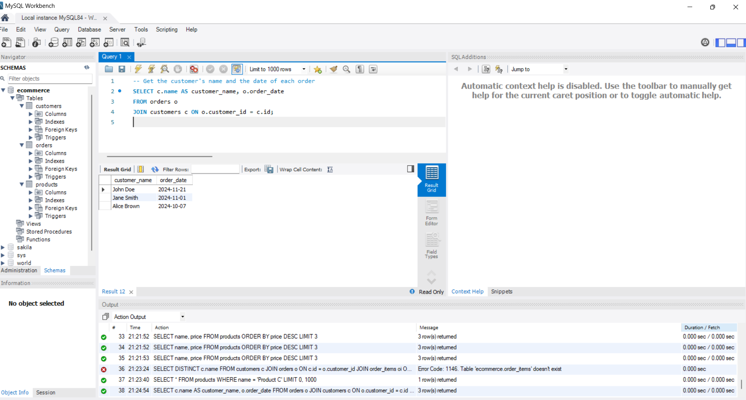

**h. Retrieve orders with a total amount greater than 150.00**

-- Fetch all orders with a total amount greater than 150.00

SELECT id AS order_id, customer_id, total_amount

FROM orders

WHERE total_amount > 150.00;

**Output:**

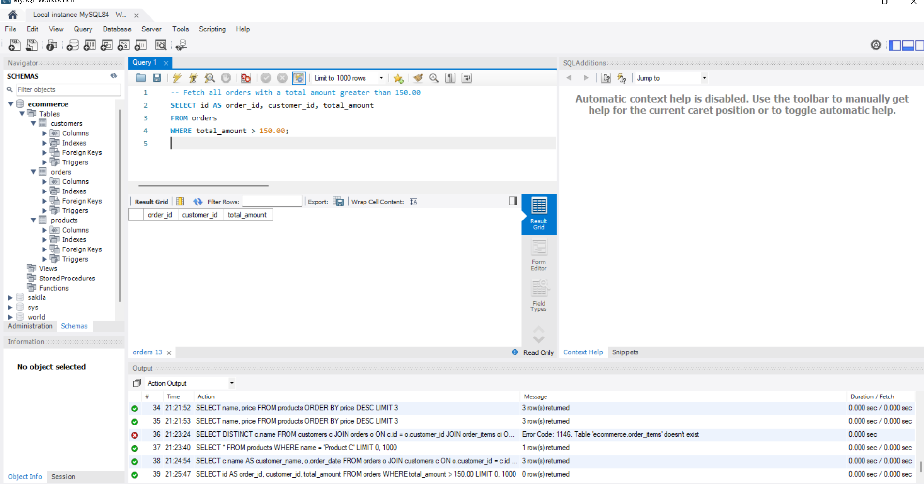

**i. Normalize the database (add order_items table)**

**-- Create the 'order_items' table to store details of individual items in an order**

CREATE TABLE order_items (

id INT AUTO_INCREMENT PRIMARY KEY, -- Unique identifier for each order item

order_id INT NOT NULL, -- ID of the order

product_id INT NOT NULL, -- ID of the product

quantity INT NOT NULL, -- Quantity of the product ordered

FOREIGN KEY (order_id) REFERENCES orders(id), -- Link to the 'orders' table

FOREIGN KEY (product_id) REFERENCES products(id) -- Link to the 'products' table

);

**-- Remove the 'total_amount' column from the 'orders' table to calculate it dynamically**

ALTER TABLE orders DROP COLUMN total_amount;

**-- Insert sample data into the 'order_items' table**

INSERT INTO order_items (order_id, product_id, quantity)

VALUES

(1, 1, 2), -- 2 units of Product A

(2, 2, 3), -- 3 units of Product B

(3, 3, 1); -- 1 unit of Product C

**Output:**

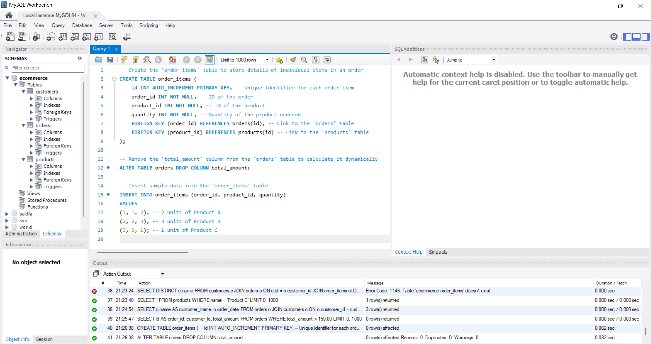

**j. Retrieve the average total of all orders**

**-- Calculate the average total amount for all orders dynamically**

SELECT AVG(oi.quantity * p.price) AS average_order_total

FROM orders o

JOIN order_items oi ON o.id = oi.order_id

JOIN products p ON oi.product_id = p.id;

**Output:**

